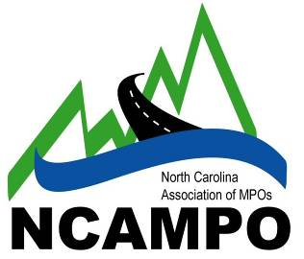
North Carolina Association of Metropolitan
Planning Organizations
2015 Annual Conference:
“At the Crossroads”

Call for Presentations

Conference: April 29 – May 1, 2015 in Downtown Raleigh, NC
Proposal deadline: December 31, 2014

About the Conference
The 2015 North Carolina MPO Conference will be an excellent continuing educational opportunity that will attract a diverse range of transportation planning professionals. The Conference features a comprehensive array of high quality technical sessions, special speakers, and timely agency updates. More than 300 participants from MPOs, RPOs, NCDOT, the consultant community, transit agencies, and other organizations are expected to attend the conference. While transportation planners, engineers, and consultants make up the core participants, the conference also offers an opportunity for transit administrators, elected officials, land-use planners, students, and others to learn more about a variety of transportation related topics.

Registration costs and hotel rates are being finalized, but for budgeting purposes, we anticipate the registration fee to be between $175 and $200, with a discount for students. The conference hotel is the Sheraton Raleigh, and the room rate is $169 for single or double occupancy. All presenters must register for the conference and pay the conference registration fee to attend the conference; being accepted as a presenter does not register you.

Most of the technical sessions will occur on April 30th, with two 90-minute time slots in the morning and two in the afternoon. Some sessions may be scheduled on the afternoon of April 29th as well. Three sessions will run concurrently during each time slot, for a total of 12-15 sessions. Each session is typically 90 minutes and features an average of three speakers with time for questions, so each presentation averages approximately 20 to 30 minutes in length.

The conference is presented by the NC Association of Metropolitan Planning Organizations and the NC Association of Rural Planning Organizations in cooperation with NCDOT. When available, more detailed conference information will be posted at http://www.ncampo.org/ncampoconference.htm

Proposal Guidelines
Presentation proposals for conference technical sessions should be submitted on the attached form. E-mail your submissions using the attached form to the Capital Area MPO at conf@ncampo.org by December 31, 2015. We hope to notify you by February 13th if your proposal has been selected.

Questions?
More information about the conference, program, sponsorship opportunities, and mobile workshops will be posted on the conference website as it becomes available. For questions regarding proposals, contact Shelby Powell at Shelby.Powell@campo-nc.us or (919) 996-4393.

Suggested Topics
We are particularly interested in presentations related to the following topics, but we will also consider proposals on topics not listed here.

Linking Land Use and Transportation: Balancing multimodal needs, scenario planning, innovative corridor plans, parking policy, project implementation
Planning Process: Regional planning and coordination, community involvement; political issues, planning for implementation
Technical Methods: GIS, modeling, and other tools to support planning and decision-making
Bicycle & Pedestrian Transportation: Planning, project implementation, case studies, funding, best practices
Public Transportation: Funding, coordinated planning, best practices, transit-oriented development
Finance: Public-private partnerships, legislative opportunities, local funding options, and other innovative approaches
Navigating the Regulatory Environment: Meeting new requirements of MAP-21, such as visualizations, or other relevant legislation
Public Involvement: Techniques, concepts, case studies, resources
Environment: Air quality, public health, social issues/environmental justice
Design: Complete streets, context-sensitive solutions, innovative projects, safety, security
Freight: Congestion, ports, economics
MPO/RPO Administration: navigating the State Ethics laws, updating administrative or policy documents, innovative approaches to planning organization administration
Project development: environmental study issues, permitting, stakeholder involvement, integration with the transportation systems planning process, and meeting community needs
State Transportation Issues: statewide planning, strategic highway corridors, investment, and implementation
Best Practices: Successful planning initiatives that involve some of the elements of other topics, case studies and best practices not addressed by other topics, and new approaches to old problems.

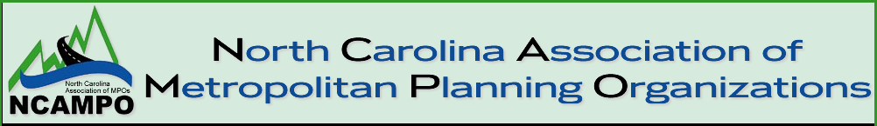
NC Association of MPO’s Annual Transportation Planning Conference
April 29 – May 1, 2014
Raleigh Convention Center
Presentation Submittal Request
The call for sessions is open from December 1, 2014 – December 31, 2014. You will be notified in early February 2015 if your session has been accepted for the conference. Each session at the conference will be 90 minutes in length, comprised of up to three presentations. Please return this completed form to Conf@ncampo.org no later than December 31, 2014. More information regarding the Conference will be posted to www.ncampo.org as it becomes available.
Presentation Title:
Presentation Description:
Expected Presentation Length: ☐ 30 minutes ☐60 minutes ☐90 minutes
Presentation Learning Objectives:
Speaker #1 Name:
Speaker #1 Bio:
Speaker #2 Name:
Speaker #2 Bio:
Speaker #3 Name:
Speaker #3 Bio:
Who should we contact about this session?
Name:
Title:
Organization:
Email:
Phone:

